**Bangladesh University of Business and Technology (BUBT)**

Department of Computer Science and Engineering



Project Report on

## Restaurant Management System

Software Development Project 03 (CSE 300)

**Submitted To**

**Md Nahid Nawaz**

Lecturer

Department of CSE BUBT

#### Submitted By

|  |  |
| --- | --- |
| **Name** | **ID** |
| Israt Jahan Urme | 16172103268 |
| Maruf Ahmed Rahad | 16172103253 |
| Kamrun Nahar Pinky | 16172103264 |

i

# ACKNOWLEDGEMENTS

We take this occasion to thank God, almighty for blessing us with his grace and taking our endeavour to a successful culmination. We extend our sincere and heartfelt thanks to our esteemed project adviser **Mr. Nahid Neyaz**, Lecturer, Department of CSE, BUBT for his invaluable guidance during the course of this project work. We extend my sincere thanks to him for his continuously helped throughout the project and without his guidance, this project would have been an uphill task. Last but not the least, we would like to thank friends for the support and encouragement they have given us during the course of our work.

**Israt Jahan Urme**

#### Maruf Ahmed Rahad

#### Kamrun Nahar Pinky

**ABSTRACT**

The purpose of this study was to develop a **Restaurant Management System** (RMS) to assist in the management of accounting with the process of doing this job earlier than pen and paper- based management. So, the development of online-based site RMS introduces the automation in the Restaurant to serving this purpose. This project is carried out as a partial fulfilment of the course Software Development Project - 3. Nowadays this kind of application is very essential for any small or medium sized Restaurant. A manager must maintain the system. This application will here to show the item list, calculate the item rate, make a bill with a receipt deposits from members, table booking,home delivery. All the information are stored in database to see further days to judge everything. The technology platform in implementing this system by using php, environment design with CSS and HTML and MYSQL database.

# DEDICATION

We would like to dedicate this site to our parents & teachers.

iv

# INDEX

|  |  |
| --- | --- |
| **Contents** | **Page** |
| Acknowledgement | i |
| Abstract | ii |
| Dedication | iii |
| Tables of Contents | iv |
| List of Figures | vii |
| List of Abbreviations | viii |

## Chapter 1: Introduction

|  |  |
| --- | --- |
| 1.1 | Introduction |
| 1.2 | Motivation |
| 1.3 | Project Objectives |
| 1.4 | Key Benefits |
| 1.5 | Organization of this project |
| 1.6 | Conclusion |

**Chapter 2: Background Knowledge**

|  |  |
| --- | --- |
| 2.1 | Introduction |
| 2.2 | Literature Review |
| 2.3 | Problem Statement |

**Chapter 3: Proposed System Analysis and Design**

**1-3**

|  |
| --- |
| 1 |
| 2 |
| 2 |
| 2 |
| 3 |
| 3 |

#### 4-5

|  |
| --- |
| 4 |
| 4 |
| 5 |

**6-13**

|  |  |
| --- | --- |
| 3.1 | Introduction |
| 3.2 | System Analysis |
| 3.3 | System Requirements |
| 3.3.1 | Functional Requirements |

|  |
| --- |
| 6 |
| 6 |
| 7 |
| 7 |

|  |  |
| --- | --- |
| 3.3.2 | Non-Functional Requirements |
| 3.4 | Database Design Model |
| 3.4.1 | Relational DBMS(RDBMS) |
| 3.4.2 | Advantage of RDBMS |
| 3.5 | Data Model |
| 3.5.1 | Client Tier |
| 3.5.2 | Business Tier |
| 3.5.3 | Data Tier |
| 3.5.4 | Database Theory |
| 3.6 | Relational Database |
| 3.6.1 | Primary Key |
| 3.6.2 | Foreign Key |
| 3.7 | Structured Query Language(SQL) |
| 3.8 | Relational Model of The Used Database |
| 3.8.1 | User table |
| 3.8.2  3.8.3  3.9 | Special Customer Table Bill Table  E-R Diagram |

|  |
| --- |
| 7 |
| 8 |
| 8 |
| 9 |
| 10 |
| 10 |
| 10 |
| 10 |
| 10 |
| 10 |
| 10 |
| 10 |
| 11 |
| 12 |
| 12 |
| 12  12  14 |

## Chapter 4: User Manual 15-30

|  |  |
| --- | --- |
| 4.1 | Welcome And Login Page |
| 4.2 | Item Category Selection Page |
| 4.3 | Burger Item Page |
| 4.4 | Pizza Item Page |
| 4.5 | Chicken Item Page |
| 4.6 | Drinks Item Page |
| 4.7 | Manager’s Page |
| 4.8 | Special Customer Page |
| 4.8.1 | Special Customer Page (after adding Information) |

|  |
| --- |
| 15 |
| 16 |
| 17 |
| 18 |
| 19 |
| 20 |
| 21 |
| 22 |
| 23 |

|  |  |
| --- | --- |
| 4.9 | Bill And Judge Page |
| 4.10 | Making Bill Page |
| 4.10.1 | Making Bill Page(Adding Value Of Each Box) |
| 4.10.2 | Bill Showing PDF Format |
| 4.11 | Judging Page |
| 4.12 | Judging Item |
| 4.13 | Judging Burger |
| 4.14 | Judging Chicken |
| 4.15 | See Total Amount Database |

|  |
| --- |
| 24 |
| 25 |
| 26 |
| 27 |
| 28 |
| 28 |
| 29 |
| 30 |
| 30 |

## Chapter 5: Tools and Technology Used

|  |  |
| --- | --- |
| 5.1 | Development Tools |
| 5.1.1 | HTML |
| 5.1.2 | MySQL Database |
| 5.1.3 | CSS |
| 5.16 | Pixie |

**Chapter 6:Conclusion**

**31-34**

|  |
| --- |
| 31 |
| 31 |
| 31 |
| 32 |
| 33 |
|  |
| 34 |

#### 35

|  |  |
| --- | --- |
| 6.1 | Introduction |
| 6.2 | Limitations |
| 6.3 | Future Goals |

|  |
| --- |
| 35 |
| 35 |
| 35 |

## References 37

**List of Figures**

vii

|  |  |  |
| --- | --- | --- |
| **Figure No.** | **Title of Figure** | **Page No.** |
| **Figure 3.1**  **Figure 4.1:** | E-R Diagram  Welcome And Login Page | 14  15 |
| **Figure 4.2:** | Item Category Selection Page | 16 |
| **Figure 4.3:** | Burger Item Page | 17 |
| **Figure 4.4:** | Pizza Item Page | 18 |
| **Figure 4.5:** | Chicken Item Page | 19 |
| **Figure 4.6:** | Drinks Item Page | 20 |
| **Figure 4.7:** | Manager’s Page | 21 |
| **Figure 4.8:** | Special Customer Page | 22 |
| **Figure 4.8.1:** | Special Customer Page (after  adding Information) | 23 |
| **Figure 4.9:** | Bill And Judge Page | 24 |
| **Figure 4.10:** | Making Bill Page | 25 |
| **Figure 4.10.1:** | Making Bill Page(Adding  Value Of Each Box) | 26 |
| **Figure 4.10.2:** | Bill Showing PDF Format | 27 |
| **Figure 4.11:** | Judging Page | 28 |
| **Figure 4.12:** | Judging Item | 28 |
| **Figure 4.13:** | Judging Burger | 29 |
| **Figure 4.14:** | Judging Chicken | 30 |
| **Figure 4.15:** | See Total Amount Database | 30 |

### viii

**List of Abbreviations**

|  |  |
| --- | --- |
| **RMS** | Restaurant Management System |
| **BUBT** | Bangladesh University of Business and Technology |
| **PDF** | Portable Document Format |
| **SQL** | Structured Query Language |
| **E-R** | Entity Relationship |
| **ERD** | Entity Relationship Diagram |
| **RDBMS** | Relational Database Management System |
| **IDE** | Integrated Development Environment |
| **GUI** | Graphical User Interface |
| **HTML** | Hypertext Mark-up Language |
| **XSLT** | Extensible Style sheet Language Transformations |
| **CSS** | Cascading Style Sheets |
| **XML** | Extensible Mark-up Language |
| **FCL** | Framework Class Library |
| **UWP** | Windows Platform |
| **API** | Application Programming Interface |
| **RGB** | Red Green Blue |
| **CYMK** | Cyan, Magenta, Yellow, Key (Black) |
| **CLR** | Common Language Runtime |
| **UML** | Unified Modelling Language |
| **CSE** | Computer Science and Engineering |

**CHAPTER 1 INTRODUCTION**

* 1. **Introduction**

Each cities or area or region have lots of restaurant for providing food to customers. The main aim behind this project is to get the current status of restaurant , to manage details it will handle only the sales information and total income states. The software also provides the sales rate and date to date calculations of each item category used. The software records daily customer list, purchased items by customer and the amount of money through its category . In the software we are maintaining the entire detail of the food items in short. It also includes options such as adding the special member information, updating the member information, deleting the member information. The delete option has some constraints, the member should not have any liabilities. We are not providing the shopping rate of last any days so the expense rates cannot be known. The software also includes a standard chart of item list and with the amount of that item and the customer can only see the item list and it’s amount but camnot enter the main base. Besides ,at the time of making bill payment receipt the amount of the item will show atumatically,that’s why the manager doesn’t need to know the price of the item. In this option backup of the entire software information can be stored in the database with date, if in case the data gets lost we can retrieve the lost data from the database. This project can be merged with any major projects where sales and bill calculations need to be done. Also, it has a facility to maintain a database of all the selling item. This software can be used in general in any institution, hotels, canteen, etc which is maintaining a restaurant or cafe. We can improve the efficiency of the restaurant management, thus overcome the drawbacks of the existing management.

The system will do the following activities:

* + 1. Special member registration
    2. Remove member from the system
    3. Amount of every item
    4. Making bill calculation
    5. Item tracking
    6. Item rate calculation
    7. Make each item bill and total bill
    8. Export bill as PDF
    9. Judge item
    10. Total salling amount date to date

#### Motivation

The project aims to develop a system is for any type of document but nothing particular. This system is revolutionary to document processing. The uniqueness is being desktop based offline application and for general-purpose. This system available in a single computer. But it’s database can be access through local area network if database in a server computer. This system is developing by .Net Framework which followed the code first approach. To develop a database system which can easily store, retrieve and delete data .

## Project Objectives

The objectives of the project are follows:

* + 1. To make a system that reduce the time to maintain a restaurant.
    2. To keep track of members records.
    3. To calculate item rate correctly.
    4. To keep special members biodata in electronic media.
    5. To keep track of total sales

## Key Benefits This system has many features.

Some of them are below:

#### User Friendly Interface

The user interface is just awesome. Anybody can operate the software with some basic knowledge of computer.

#### Admin

Privileges In this system, manager play the admin role. Manager can add, view, remove member, set bill to members etc.

#### Security

Login system is implemented. So, only manager can control the operations and member can only view. All activities are recorded in database and available to all members.

#### Time Savings

In manual system, it is very time consuming for recording, calculating item rates, searching and judging all etc. But in this system, it is very easy to do them by clicking on few buttons.

#### Report Generates

By using this system, we can filter any data of a table by date range and export the report in PDF format.

## Organization of This Project

In chapter one, we introduce the system and write about motivation, project objectives and key benefits of the system. In chapter two, we give literature review on whole project. In chapter three, we give information about our proposed system, database structure, E-R diagram. In chapter four, we show user manual. In chapter five, we give information about the working tools. Finally, we discuss about our future goal, limitations and conclude about the system.

## Conclusion

The main objective of the project is to establish an integrated restaurant management system which enables us to automate the dynamic Administrative process in the restaurant. Establishing a strong and effective Management System. Achieving integration between developed management system and other available systems. Preparing electronic data that enable the process entering and converting data.

# CHAPTER 2

**BACKGROUND KNOWLEDGE**

## Introduction

Nowadays, many management systems are having developed rapidly. Those management systems are developed on the purpose to overcome the problems that faced by manual method and it is also can ease up the user to do their daily work. Development of computer-based system provides more benefits and influences that can shape and create the work culture more systematic and can change the administrative structure of an organization to be more quickly and effectively. Hence, we would like to propose the idea of Restaurant Management System. Restaurant Management System is a system that develops to change manual system used in restaurant. It can be applying by customers who come in restaurant . Through this system, user will be able to record all information about and complaint that was made into single database. Besides, they also can use this system to keep tracking about their sales item,item rate etc. Every data can be search, add, and also delete. For members, they could only do update their profile, view activities, records and export them as PDF. If they forget their password, they can reset it by using their secret pin number. If they also forget the secret pin number then they must contact with manager. Additionally, Restaurant Management System is easier to use .

## Literature Review

A system is a whole that cannot be decomposed into independent parts. It follows a research approach. Research Approach begins by analysing so as to identify its parts and interconnections. This approach follows the technical aspects of the socio-technical systems. This approach involves a concept of planning as a structured process and has five phases: formulating the restaurant, ends planning, means planning, resource planning and design of implementation and control. Research is heavily used in inventing, elaborating and implementing

new ideas. This project is carried out to assess student’s skills and knowledge in systems engineering. This project has 5 modules. They are member information maintenance, bill maintenance, amount maintenance ,item maintenance and report generation. The project is developed using C# methodology. During system development, Microsoft visual studio is used for developing the GUI & implementing the functionality while MySQL is used for creating and manipulating the database. This project has undergone several phases. There are planning analysis, design, development and testing. First, in the planning of this project, plan is written. Next, during analysis stage, system requirements specification and activity diagram modelling the current system are produced. In design stage, various UML diagrams such as use case

diagram, sequence diagram, class diagram and etc are drawn. A computer-based management system is designed to handle all the primary information required to calculate monthly statements. Separate database is maintained to handle all the details required for the correct statement calculation and generation. This project intends to introduce more user friendliness in the various activities such as record updating, maintenance, and searching. Similarly, record maintenance and updating can also be accomplished by using the identification of the customer with all the details being automatically generated. These details are also being promptly automatically updated in the master file thus keeping the record absolutely up-to-date. The entire information has maintained in the database or Files and whoever wants to retrieve can’t retrieve, only authorization user can retrieve the necessary information which can be easily be accessible from the database. For designing the system, we have used simple data flow diagrams. Overall the project teaches us the essential skills like: Using system analysis and design techniques like data flow diagram in designing the system, Understanding the database handling and query processing, etc .

## Problem Statement

The growing number of customers in higher restaurent all over the world has posed a lot of accommodation problem on the part of customer and restaurant management. The item list side is static.The item cannot be changed daynamically.In this process the manager should know how add the item in the form or should manage a specialist.

# CHAPTER 3

**PROPOSED SYSTEM ANALYSIS AND DESIGN**

## Introduction

Requirements analysis in systems engineering and software engineering. encompasses those tasks that go into determining the needs or conditions to meet for a new or altered product, taking account of the possibly conflicting requirements of the various stakeholders, such as beneficiaries or users. Another requirement you need to have to be a software manager you need to know how to pleasure your boss. But in financing you also need to pleasure your boss . Requirements analysis is critical to the success of a development project. Requirements must be documented, actionable, measurable, testable, related to identified business needs or opportunities, and defined to a level of detail sufficient for system design. Requirements can be architectural, structural, behavioural, functional, and non-functional .

## System Analysis

System analysis is the process of gathering and interpreting facts, diagnosing problems and using the information to recommend improvements on the system. System analysis is a problem- solving activity that requires intensive communication between the system users and system developers. System analysis or study is an important phase of any system development process. The system is viewed as a whole, the inputs are identified and the system is subjected to close study to identify the problem areas. The solutions are given as a proposal. The proposal is reviewed on user request and suitable changes are made. This loop ends as soon as the user is satisfied with the proposal.

The existing system is not totally automated. Though the system is computerized to a particular extent, it has not to do a lot of manual work. The different processes involved are:

1. User friendly.
2. Less human error.
3. High security.
4. Easy data uploading.
5. Easy record keeping.
6. Backup data can be easily generated.

## System Requirements

A Software requirements specification report basically describes and environment for software/application under development. It completely describes the yield, cost, nature of the software/application.

## Functional Requirements:

* + - 1. System will have 1 types of user called Customer.
      2. System will have secure Login and Registration functionality.
      3. Everyone will have a unique name.
      4. Manager can add, view, delete, remove member from the system.
      5. Member can view item list and its price only.
      6. Manager can setup receipt and calculate total bill.
      7. Everyone can choose their items.
      8. Nobody has permission to see other customer’s activities .
      9. Manager can see total amount and judge everyitem and rating.

## Non-Functional Requirements

#### Safety Requirements

If there is extensive damage to a wide portion of the database due to catastrophic failure, such as a disk crash, the recovery method restores a past copy of the database that was backed up to archival storage (typically tape) and reconstructs a more current state by reapplying or redoing the operations of committed transactions from the backed-up log, up to the time of failure.

#### Security Requirements

Security systems need database storage just like many other applications. However, the special requirements of the security market mean that vendors must choose their database partner carefully.

#### Software Quality Attributes

1. **Correctness:**

The system should generate an appropriate report about different activities of the mess and should keep track of all records.

#### Maintainability:

The system should maintain item and calculate item rate correctly.

#### Usability:

The system should satisfy a maximum number of user’s needs.

## Database Design Model

We have used relational database design model in MMS. Now we are going to tell about the model briefly.

## Relational DBMS(RDBMS)

A Relational Database Management System (RDBMS) is a software system that provides access to a relational database. The software system is a collection of software applications that can be used to create, maintain, manage and use the database. A "relational database" is a database structured on the "relational" model.

## Advantage of RDBMS

There are many advantages of RDBMS. Some of them are below:

#### Data Structure

The table format is simple and easy for database users to understand and use. RDBMSs provide data access using a natural structure and organization of the data. Database queries can search any column for matching entries.

#### Multi-User Access

RDBMSs allow multiple database users to access a database simultaneously. Built-in locking and transactions management functionality allow users to access data as it is being changed, prevents collisions between two users updating the data, and keeps users from accessing partially updated records.

#### Privileges

Authorization and privilege control features in an RDBMS allow the database administrator to restrict access to authorized users, and grant privileges to individual users based on the types of database tasks they need to perform. Authorization can be defined based on the remote client IP address in combination with user authorization, restricting access to specific external computer systems.

#### Network Access

RDBMSs provide access to the database through a server daemon, a specialized software program that listens for requests on a network, and allows database clients to connect to and use the database.

#### Maintenance

RDBMSs feature maintenance utilities that provide database administrators with tools to easily maintain, test, repair and back up the databases housed in the system. Many of the functions can be automated using built-in automation in the RDBMS, or automation tools available on the operating system.

#### Language

RDBMSs support a generic language called "Structured Query Language" (SQL). The SQL syntax is simple, and the language uses standard English language keywords and phrasing, making it fairly intuitive and easy to learn. Many RDBMSs add non-SQL, database-specific keywords, functions and features to the SQL language.

## 3.5 Data Model

This desktop-based application is based on 3-tier architecture of .Net framework. The 3-tier includes the three hierarchy of the flow of programming logic from user interface to database

and again database to user interface with the desired intimation requested by the clients in between them involves the logical layer for effectively and correctly manipulating the request. the 3-tier includes the following.

1. Client Tier
2. Business Tier
3. Data Tier

## Client Tier

The visual part is implemented using all kinds of swing components. which does not make database call. The main function of their tier is to display information to the user upon user's request generated by user's inputs such as tiring button events. For example, deposit button will deposit money to member’s account.

## Business Tier

The middle tier, business logic, is called by the client to make database queries. It provides core function of the system as well as connectivity to the data tier. which simplify tasks that were done by the client's tier.

## Data Tier

Data layer is also the class which gets the data from the business tier and sends it to the database or gets data from the database and sends it to business tier. This is the actual DBMS access layer or object layer also called the business object. The database backend stories information which can be retrieved by using the MySQL database connectivity. MySQL database connectivity is used to manage the communication between the middle tier and the backend database by issuing complex database queries.

## Database Theory

A database (DB), in the most general sense, is an organized collection of data. More specifically, a database is an electronic system that allows data to be easily accessed,

manipulated and updated. In other words, a database is used by an organization as a method of storing, managing and retrieving information. Modern databases are managed using a database management system (DBMS).

## Relational Database

A relational database is a set of formally described tables from which data can be accessed or reassembled in many different ways without having to reorganize the database tables. The standard user and application programming interface (API) of a relational database is the Structured Query Language (SQL). SQL statements are used both for interactive queries for information from a relational database and for gathering data for reports. MMS used the relational database.

## Structured Query Language (SQL)

The Structured Query Language (SQL) is the set of instructions used to interact with a relational database. Infect, SQL is the only language that most of the database actually understands. Whenever we interact with such a database, the software translates our commands into SQL, statement that the database knows how to intercept. SQL has major three components.

1. Data Manipulation Language (DML)
2. Data Definition Language (DDL)
3. Data Control Language (DCL)

## Relational Model of the Used Database (pure database table model)

The relational model used the basic concept of a relation or table. The columns or fields in the table identify the attributes.

## User Table

Here manager can set his username and password for login processing.



After entering the login table looks like this.Here the default username password is admin admin.It can be changed into anything according to manager’s wish through change password.



## Special Customers Table (pure database table model)

Here manager can enter the information of a special customer’s information to provide discount to customers.The informations are name,phonenumber and id .



After entering data the real database table model looks like this.user can search from this table.

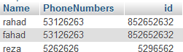

## Bill Table (pure database table model)

Here manager upload the every information of the customer’s activities. Name, his Purchased items, quantity, discount, after discount the amount of bill, is rating for the actual item and date. from this table the total amount of date to date search, total amount through item search, item judgement through rating can be happened.



After entering Information the table looks like this.

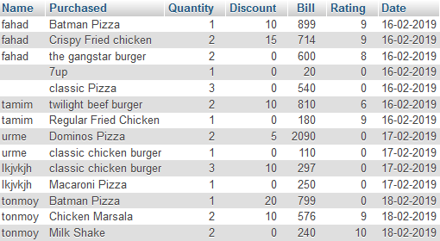

## Entity Relationship Diagram for Used Database

ID

### Login

Admin

Name

Account

### General

Password

### Control

Name

Image

Menu

Billing

ID

Name

Manager

Price

ID

Total Amount

Special Customer

Item

comment

ID Mobile

Name

**Figure 3.9: E-R Diagram for Used Database**

# CHAPTER 4 USER MANUAL

## Welcome and Login Page:

This is the login page. Manager can login their account using their username and password. System records the username and identifies the role then display the contents according logged user’s role. Manager will get access of all pages after successful login but customer has limitation over contents.

Customer can see the item category by clicking customer button. Default manager account access is:

#### Username: admin Password: admin

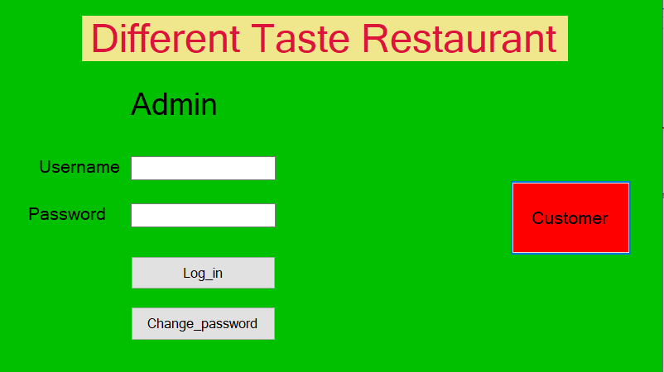

**Figure 4.1**: Welcome and Login Page

## Item Category Selection Page

This is a item category page.Here customer can choose category according to wish. This page is come after clicking the customer button in from the loggin page.

By clicking category customer can go to the item list and price page.

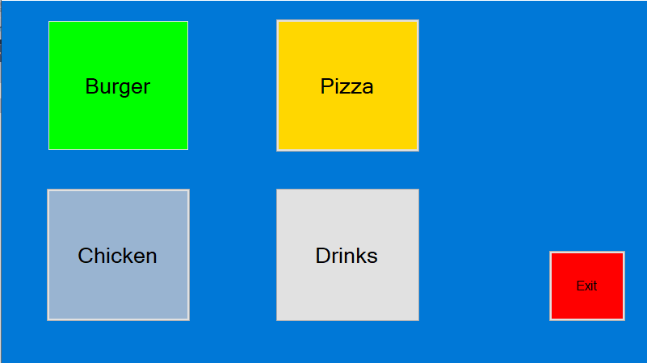

**Figure 4.2:** Item Category Selection Page

## Burger Item Page

This page is a list of different burger and its price.customer and manager both can see this.

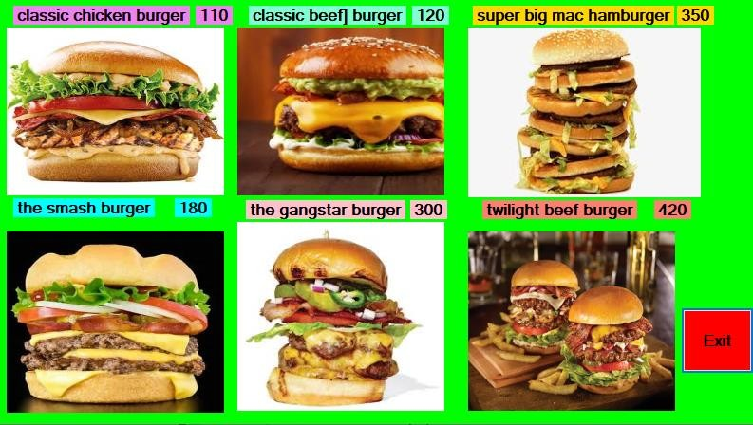

**Figure 4.3:** Burger Item Page

## Pizza Item Page

This page is a list of different Pizza and its price.customer and manager both can see this.

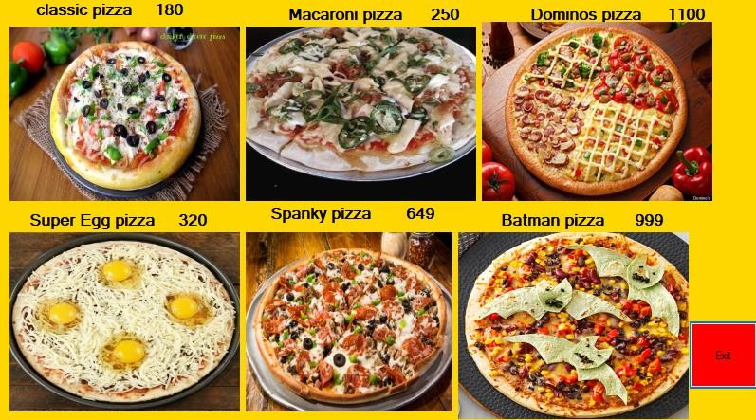

**Figure 4.4:** Pizza Item Page

## Chicken Item Page

This page is a list of different chicken and its price.customer and manager both can see this.

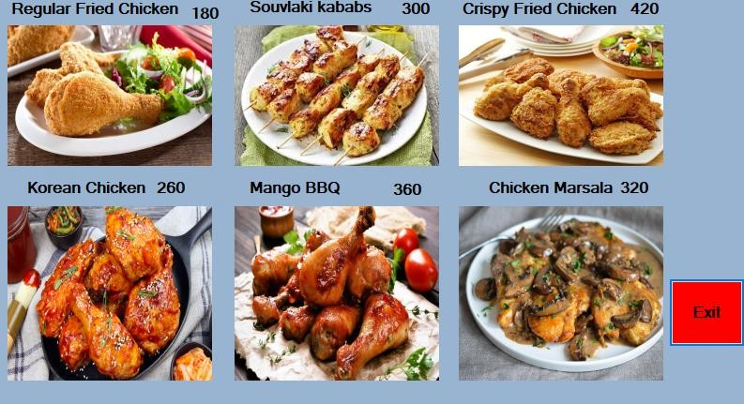

**Figure 4.5:**Chicken Item Page

## Drinks Item Page

This page is a list of different Drinks and its price.customer and manager both can see this.

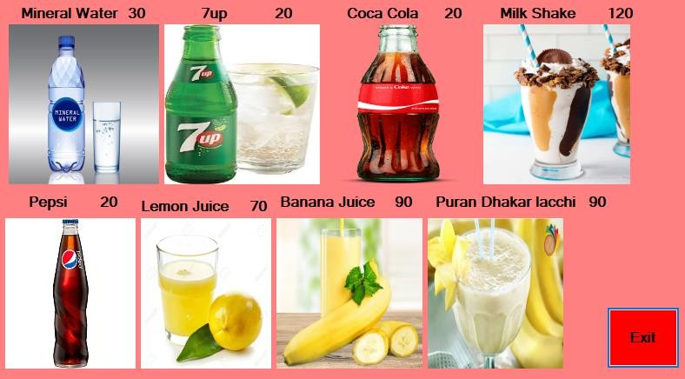

**Figure 4.6:** Drinks Item Page

## Manager’s Page

This is a manager’s page.From here manager can go to to item list,specialcustomer’s page and bill and payament page.

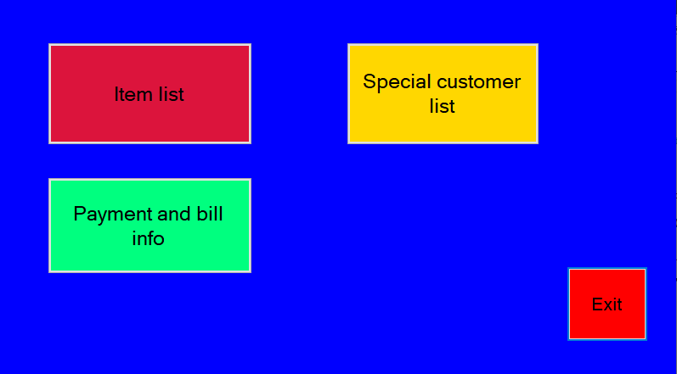

**Figure 4.7:** Manager’s Page

## Special customer’s Page (only for manager)

Here manager can add,remove special customer,delete all the information,viw all list ,search customer name through suffix or prefix.

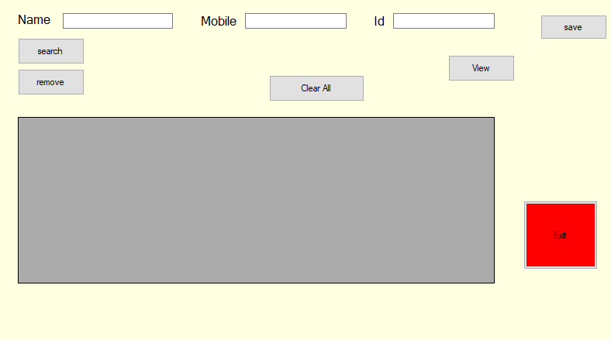

**Figure 4.8:** Special customer’s Page (only for manager)

After adding all information view all information.

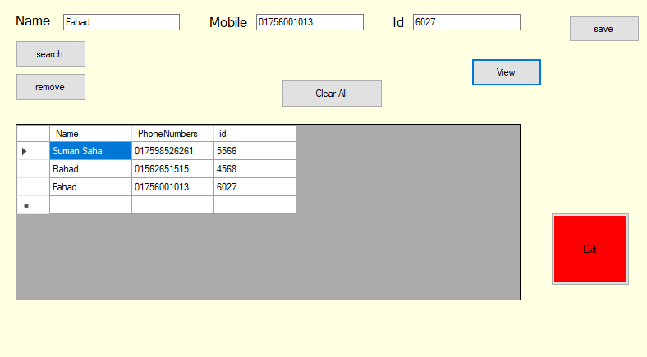

**Figure 4.8.1:** Special customer’s Page (After adding all information)

## Bill and judge Page (only for manager)

From here manager can go to creating bill page by clicking create bill button. Here manager can view all bill.

Judge item through item through judge item button.

Date to date total amount or date to date toatal category sell.

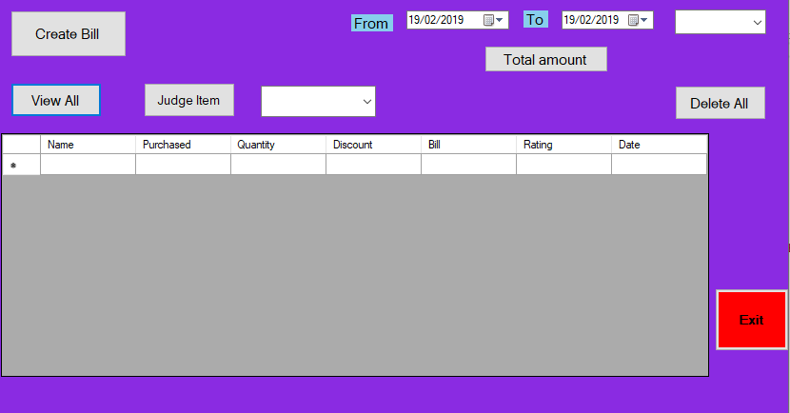

**Figure 4.9:** Bill and judge Page (only for manager)

## Making Bill page (only for manager)

From this page manager can make bill of the item for all the customer.

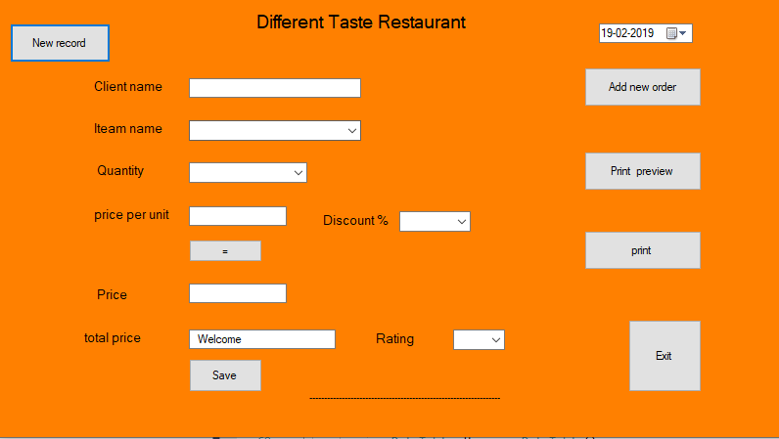

**Figure 4.10:** Making Bill page (only for manager)

After adding value of each box

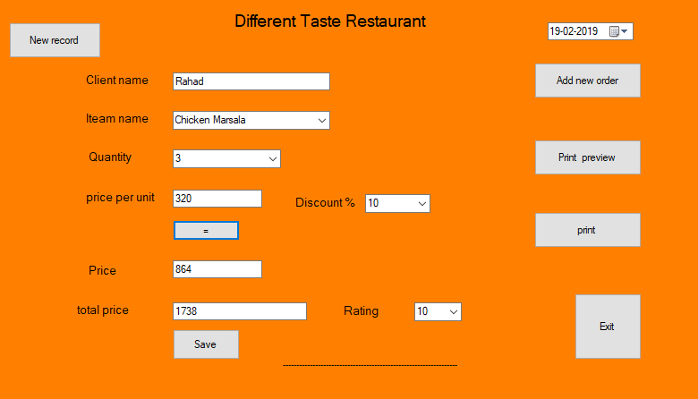

**Figure 4.10.1:** Making Bill page (adding value of each box)

## 4.10.2 Bill showing pdf format (only for manager)

This page is made by manager for customer .This have the information of time and date and every purchased item ,quantity, discount, price and total price.

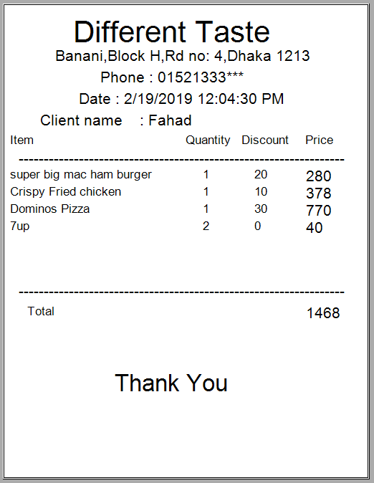

**Figure 4**.**10.2**: Bill showing pdf format (only for manager)

28

## Judging page (only for manager)

View all item

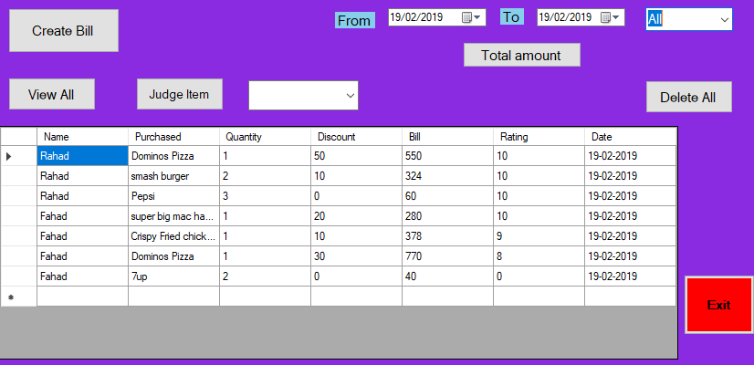

**Figure 4.11:** Judging page (only for manager)

## Judging Pizza (only for manager)

All the information of pizza that is sold with rating

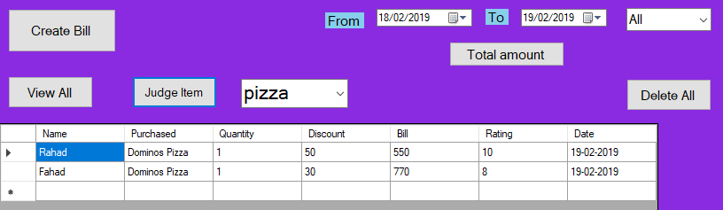

**Figure 4.12:** Judging Pizza (only for manager)

## Judging Burger (only for manager)

All the information of burger that is sold with rating

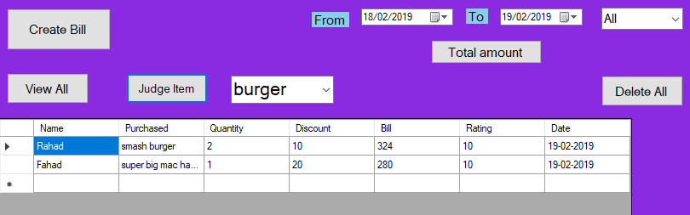

**Figure 4.13:** Judging Burger (only for manager)

## Judging Chicken (only for manager)

All the information of chicken that is sold with rating

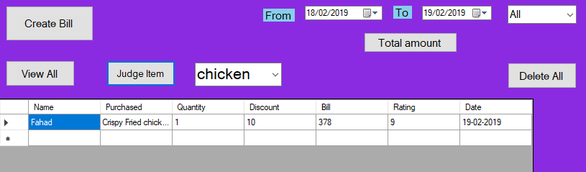

**Figure 4.14:** Judging Burger (only for manager)

## See total amount date to date (only for manager)

Here manager can see total amount through date to date.

It can be seen through total amount of burger, pizza, chicken sold.

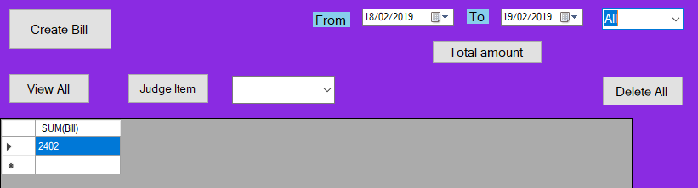

**Figure 4.15:** See total amount date to date (only for manager)

# CHAPTER 5

**TOOLS AND TECHNOLOGY USED**

## Development

Tools Many tools are used to develop the software. Some of them are used for development purpose and some of them are part of this software. Without them MMS cannot work properly.

## HTML

Hypertext Markup Language (HTML) is the standard [markup language](https://en.wikipedia.org/wiki/Markup_language) for documents designed to be displayed in a [web browser](https://en.wikipedia.org/wiki/Web_browser). It can be assisted by technologies such as [Cascading Style Sheets](https://en.wikipedia.org/wiki/Cascading_Style_Sheets) (CSS) and [scripting languages](https://en.wikipedia.org/wiki/Scripting_language) such as [JavaScript](https://en.wikipedia.org/wiki/JavaScript).

[Web browsers](https://en.wikipedia.org/wiki/Web_browser) receive HTML documents from a [web server](https://en.wikipedia.org/wiki/Web_server) or from local storage and [render](https://en.wikipedia.org/wiki/Browser_engine) the documents into multimedia web pages. HTML describes the structure of a web page [semantically](https://en.wikipedia.org/wiki/Semantic_Web) and originally included cues for the appearance of the document.

[HTML elements](https://en.wikipedia.org/wiki/HTML_element) are the building blocks of HTML pages. With HTML constructs, [images](https://en.wikipedia.org/wiki/HTML_element#Images_and_objects) and other objects such as [interactive forms](https://en.wikipedia.org/wiki/Fieldset) may be embedded into the rendered page. HTML provides a means to create [structured documents](https://en.wikipedia.org/wiki/Structured_document) by denoting structural [semantics](https://en.wikipedia.org/wiki/Semantics) for text such as headings, paragraphs, lists, [links](https://en.wikipedia.org/wiki/Hyperlink), quotes and other items. HTML elements are delineated by tags, written using [angle brackets](https://en.wikipedia.org/wiki/Bracket#Angle_brackets). Tags such as <img /> and <input /> directly introduce content into the page. Other tags such as <p> surround and provide information about document text and may include other tags as sub-elements. Browsers do not display the HTML tags, but use them to interpret the content of the page.

HTML can embed programs written in a [scripting language](https://en.wikipedia.org/wiki/Scripting_language) such as [JavaScript](https://en.wikipedia.org/wiki/JavaScript), which affects the behavior and content of web pages. Inclusion of CSS defines the look and layout of content. The [World Wide Web Consortium](https://en.wikipedia.org/wiki/World_Wide_Web_Consortium) (W3C), former maintainer of the HTML and current maintainer of the CSS standards, has encouraged the use of CSS over explicit presentational HTML since 1997.[[2]](https://en.wikipedia.org/wiki/HTML#cite_note-deprecated-2)

## MySQL Database

My SQL is an open-source relational database management system (RDBMS). Its name is a combination of "My", the name of co-founder Michael Widenius's daughter and "SQL" the abbreviation for Structured Query Language. The MySQL development project has made its source code available under the terms of the GNU General Public License, as well as under a

variety of proprietary agreements. MySQL was owned and sponsored by a single for-profit firm, the Swedish company MySQL AB, now owned by Oracle Corporation. For proprietary use, several paid editions are available, and offer additional functionality [4]. MySQL is a central component of the LAMP open-source web application software stack (and other "AMP" stacks). LAMP is an acronym for "Linux, Apache, MySQL, Perl/PHP/Python". Applications that use the MySQL database include: TYPO3, MODx, Joomla, WordPress, Simple Machines Forum, phpBB, MyBB, and Drupal. MySQL is also used in many high-profile, large-scale websites, including Google (though not for searches), Facebook, Twitter, Flickr, and YouTube [4]. MySQL is written in C and C++. Its SQL parser is written in yacc, but it uses a home-brewed lexical analyzer. MySQL works on many system platforms, including AIX, BSDi, FreeBSD, HP-UX, eComStation, i5/OS, IRIX, Linux, macOS, Microsoft Windows, NetBSD, Novell NetWare, Open BSD, Open Solaris, OS/2 Warp, QNX, Oracle Solaris, Symbian, SunOS, SCO Open Server, SCO UnixWare, Sanos and Tru64. A port of My SQL to OpenVMS also exists [4]. The MySQL server software itself and the client libraries use dual-licensing distribution. They are offered under GPL version 2, beginning from 28 June 2000 (which in 2009 has been extended with a FLOSS License Exception) or to use a proprietary license [4]. Support can be obtained from the official manual. Free support additionally is available in different IRC channels and forums. Oracle offers paid support via its My SQL Enterprise products. They differ in the scope of services and in price. Additionally, a number of third-party organisations exist to provide support and services, including Maria DB and Persona [4]. My SQL has received positive reviews, and reviewers noticed it "performs extremely well in the average case" and that the "developer interfaces are there, and the documentation (not to mention feedback in the real world via Web sites and the like) is very, very good". It has also been tested to be a "fast, stable and true multi-user, multi-threaded SQL database server" [4]. MySQL is offered under two different editions: the open source My SQL Community Server and the proprietary Enterprise

Server. My SQL Enterprise Server is differentiated by a series of proprietary extensions which install as server plugins, but otherwise shares the version numbering system and is built from the same code base [4]. MySQL is not a complete database system. It has some constraints. When using some storage engines other than the default of InnoDB, MySQL does not comply with the full SQL standard for some of the implemented functionality, including foreign key references. Check constraints are parsed but ignored by all storage engines .

## CSS

**Cascading Style Sheets** (**CSS**) is a [style sheet language](https://en.wikipedia.org/wiki/Style_sheet_language) used for describing the [presentation](https://en.wikipedia.org/wiki/Presentation_semantics) of a document written in a [markup language](https://en.wikipedia.org/wiki/Markup_language) like [HTML](https://en.wikipedia.org/wiki/HTML).[[1]](https://en.wikipedia.org/wiki/Cascading_Style_Sheets#cite_note-1) CSS is a cornerstone technology of the [World Wide Web](https://en.wikipedia.org/wiki/World_Wide_Web), alongside HTML and [JavaScript](https://en.wikipedia.org/wiki/JavaScript).[[2]](https://en.wikipedia.org/wiki/Cascading_Style_Sheets#cite_note-2)

CSS is designed to enable the separation of presentation and content, including [layout](https://en.wikipedia.org/wiki/Page_layout), [colors](https://en.wikipedia.org/wiki/Color), and [fonts](https://en.wikipedia.org/wiki/Typeface).[[3]](https://en.wikipedia.org/wiki/Cascading_Style_Sheets#cite_note-3) This separation can improve content [accessibility](https://en.wikipedia.org/wiki/Accessibility), provide more flexibility and control in the specification of presentation characteristics, enable multiple [web pages](https://en.wikipedia.org/wiki/Web_page) to share formatting by specifying the relevant CSS in a separate .css file, and reduce complexity and repetition in the structural content.

Separation of formatting and content also makes it feasible to present the same markup page in different styles for different rendering methods, such as on-screen, in print, by voice (via speech-based browser or [screen reader](https://en.wikipedia.org/wiki/Screen_reader)), and on [Braille-based](https://en.wikipedia.org/wiki/Braille_display) tactile devices. CSS also has rules for alternate formatting if the content is accessed on a [mobile device](https://en.wikipedia.org/wiki/Mobile_device).[[4]](https://en.wikipedia.org/wiki/Cascading_Style_Sheets#cite_note-4)

The name *cascading* comes from the specified priority scheme to determine which style rule applies if more than one rule matches a particular element. This cascading priority scheme is predictable.

The CSS specifications are maintained by the [World Wide Web Consortium](https://en.wikipedia.org/wiki/World_Wide_Web_Consortium) (W3C). Internet media type ([MIME type](https://en.wikipedia.org/wiki/MIME_media_type)) text/css is registered for use with CSS by [RFC 2318](https://tools.ietf.org/html/rfc2318) (March 1998). The W3C operates a free [CSS validation service](https://en.wikipedia.org/wiki/W3C_Markup_Validation_Service#CSS_validation) for CSS documents.[[5]](https://en.wikipedia.org/wiki/Cascading_Style_Sheets#cite_note-5)

In addition to HTML, other markup languages support the use of CSS including [XHTML](https://en.wikipedia.org/wiki/XHTML), [plain XML](https://en.wikipedia.org/wiki/Plain_Old_XML), [SVG](https://en.wikipedia.org/wiki/Scalable_Vector_Graphics), and [XUL](https://en.wikipedia.org/wiki/XUL).

**WEB BROWSER (chrome,Mozilla etc )**

MySQL Connector is a driver for connecting to a MySQL database server through the Open Database Connectivity (ODBC) application program interface (API), which is the standard means of connecting to any database. Users can connect from within common applications and programming environments, such as Microsoft Access or Excel or Borland Delphi [4]. MySQL Connector is available for most major operating systems, including Windows, Unix, Linux, Solaris, AIX, and OS X either under the free software/open source GNU General Public License (GPL) or under a commercial license [4].

# CHAPTER 6 CONCLUSION

## Introduction

To conclude the description about the project: The project, developed using C# and My SQL is based on the requirement specification of the user and the analysis of the existing system, with flexibility for future enhancement. The expanded functionality of today’s software requires an appropriate approach towards software development. This restaurant management software is designed for people who want to manage various activities in the restaurant. For the past few years the number of educational institutions is increasing rapidly. And hence there is a lot of strain on the person who are running the restaurant and software’s are not usually used in this context.

## Limitations

There are some drawbacks and limitations in this software as it is a beta release and under future development process.

1. Limited features, need to explore.
2. Platform is not independent. So, it may not run on different operating systems like MacOS, Ubuntu, Linux.
3. Some minor bugs exist

## Future Goals

The project has a very fast scope in future. The project can be implemented platform independent in future. Project can be updated in near future as and when requirement for the same arises, as it is very flexible in terms of expansion. With the proposed software **Restaurant Management System** is ready and fully functional for the client is now able to manage and hence run the

entire work in a much better, accurate and error free manner. The following are the future scope for the project.

1. Advance records filter options.
2. Records export in different formats like csv

# REFFERENCES

* 1. Rouse, M. (2018). Relational Database. [Blog] Search Data Management. Available at: https://searchdatamanagement.techtarget.com/definition/relational-database [Accessed 13 Sep. 2018].
  2. Nattyware.com. (1999). Pixie / Nattyware. [online] Available at: <http://www.nattyware.com/pixie.php>[Accessed 13 Sep. 2018].
  3. En.wikipedia.org. (2018). Microsoft Visual Studio. [online] Available at: https://en.wikipedia.org/wiki/Microsoft_Visual_Studio [Accessed 13 Sep. 2018]..
  4. En.wikipedia.org. (2018). MySQL. [online] Available at: https://en.wikipedia.org/wiki/MySQL [Accessed 13 Sep. 2018].
  5. Bandakkanavar, R. (2018). Software Requirements Specification Report for a Project. [Blog] Krazytech. Available at: https://krazytech.com/projects/software-requirements- specification-report [Accessed 13 Sep. 2018].
  6. En.wikipedia.org. (2018). IText. [online] Available at: https://en.wikipedia.org/wiki/IText [Accessed 1 Oct. 2018].
  7. En.wikipedia.org. (2018). .NET Framework. [online] Available at: https://en.wikipedia.org/wiki/.NET_Framework [Accessed 1 Oct. 2018].